Project Design Phase

Project Name | Streamlining Ticket Assignment for efficient operations
Date | 01/11/2025
Team ID | NM2025TMID07193

1.Proposed Solutions :
S.NO | PARAMETER | DESCRIPTION
1 | Problem statement | Manual ticket assignment is slow and inefficient, causing delays and lower customer satisfaction. We need a faster, automated way to assign tickets to the right support agents based on their skills, workload, and ticket priority.
2 | Idea/solution description | Use an automated ticket assignment system that quickly matches incoming tickets to the right support agents based on their skills, availability, and ticket priority. This will speed up response times, balance workloads, and improve customer
3 | uniqueness | The unique aspect of this solution is the smart, automated matching of tickets to agents using real-time data like skills, workload, and ticket priority. Unlike basic assignment methods, it can adapt instantly to changes, ensuring faster, fairer, and more accurate ticket distribution.
4 | Social impact/customer satisfaction | helps customers get faster, more accurate support, which increases their satisfaction and trust in the service. It also reduces stress and overload for support agents, creating a better work environment and improving overall team performance.
5 | Business model/revenue model) | The solution can be offered as a subscription-based software (SaaS), where businesses pay monthly or yearly fees based on the number of users or tickets handled. Additional revenue can come from premium features like advanced reporting, AI-based routing, and system customization.
6 | scalability of the solution | The solution can easily grow with the business by handling more tickets, agents, and support teams without losing speed or accuracy. It can be used by small teams or large organizations and can integrate with existing support tools to support future expansion

2.System Design Architecture
The system architecture integrates key ServiceNow components such as tables, groups, roles, access control lists (ACLs), and flow automation. These components collaborate to ensure that support tickets are automatically classified and assigned to the correct team. The architectural structure is divided into multiple layers:
• Data Layer – Custom tables to store ticket details.
• Application Layer – Roles, groups, and ACLs for access management.
• Automation Layer – Flow Designer for rule-based routing.
• Presentation Layer – ServiceNow form interface for issue entry and visualization.
This architecture provides both flexibility and security while maintaining data consistency across the platform.

3.Module Design and Implementation
The design phase includes configuring different modules within ServiceNow that collectively support automated ticket routing. Each component was implemented in a structured sequence to ensure modular development and ease of integration.

3.1 User, Group, and Role Creation Design
Users, groups, and roles were created in ServiceNow to define system access and manage ticket assignments efficiently. To create users, ServiceNow was opened, and under System Security → Users, new user profiles were added by clicking New, entering the required details, and clicking Submit. Multiple users were created following the same steps.
Next, groups were configured to organize users according to their responsibilities. From System Security → Groups, new groups were created, filled with the necessary information such as group name and description, and saved using Submit. Similarly, roles were established under System Security → Roles by clicking New, providing role details, and submitting them. Additional roles were also created to differentiate user permissions.
This configuration of users, groups, and roles ensures structured access control, enabling secure and efficient management of support operations within the automated ticket routing system
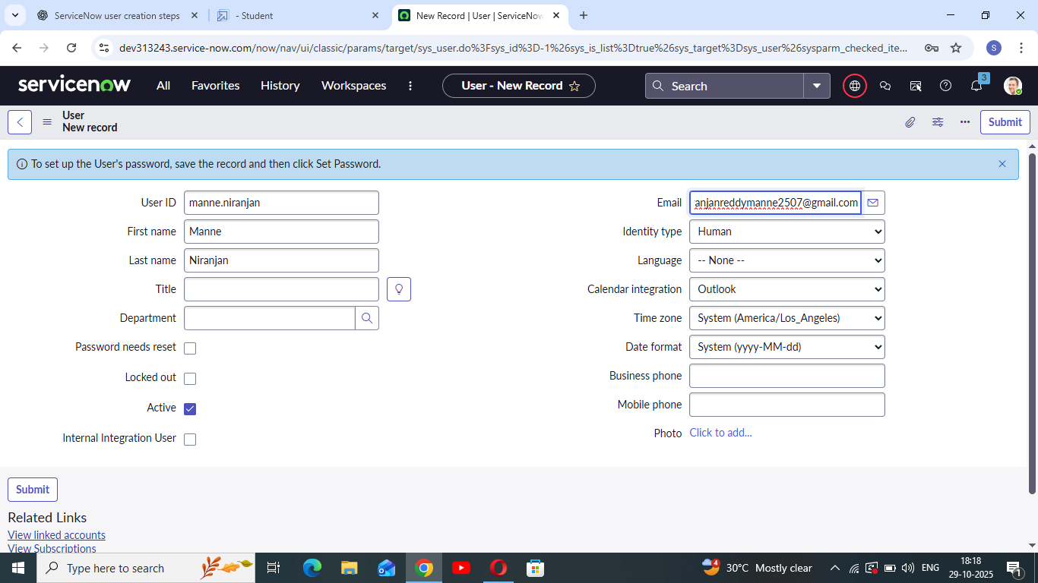

3.2 Table Design – Operations Related
A custom table named 'Operations Related' was designed to capture and store all ticket-related information. Steps for table creation:
1. Open ServiceNow → All → Search for 'Tables' under System Definition.
2. Click on 'New' and provide the following details:
• Label: Operations Related
• Checkboxes: Create Module and Create Mobile Module
• Menu Name: Operations Related
3. Define necessary table columns such as Issue, Assigned Group, and Status.
4. Click 'Submit' to create the table successfully.
This table forms the foundation for capturing issue-specific records to be routed automatically.

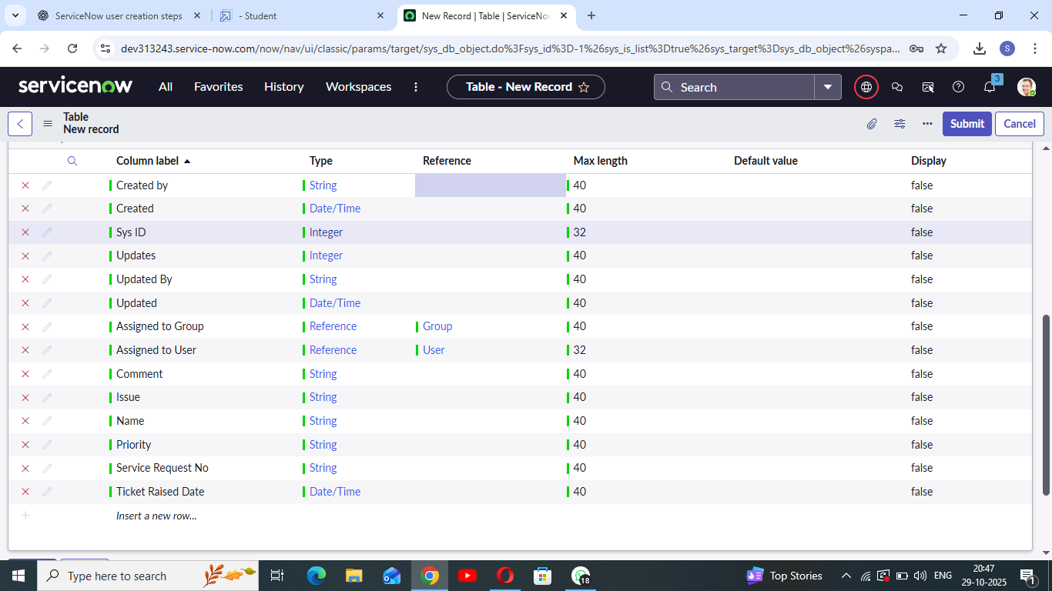

3.3 Issue Field and Choices
To classify tickets effectively, specific issue types were created as selectable options in the Issue field using Form Design. These predefined choices help in automating flow triggers.
Choices added:
• Unable to login to platform
• 404 Error
• Regarding Certificates
• Regarding User Expired
Each choice corresponds to a specific flow in the automation layer.

3.4 Group and Role Configuration
Two key groups were configured to manage support tickets based on issue type:
Certificate Group Configuration:
• Navigate to System Definition → Tables.
• Select the Certificates group → Edit Group Members → Add 'Katherine Pierce'.
• Assign Role → Select 'Certification_Role' and Save.
Platform Group Configuration:
• Navigate to System Definition → Tables.
• Select the Platform group → Edit Group Members → Add 'Manne Niranjan'.
• Assign Role → Select 'Platform_Role' and Save.
This ensures that each user has role-specific access to assigned tickets.

3.4 Role Assignment to Table
Access to the 'Operations Related' table was restricted through role mapping:
1. Navigate to the 'Operations Related' table under System Definition.
2. Select Application Access.
3. Open 'u_operations_related Read Operation'.
4. Elevate role by clicking profile → Security Admin → Update.
5. Under 'Requires Role', insert Platform_Role and Certification_Role.
6. Repeat for 'Write Operation'.
This enforces access control at the data layer ensuring authorized usage only.

3.5 Access Control List (ACL) Configuration
ACLs were created to define access rules and enhance security:
1. Navigate to All → Search 'ACL'.
2. Select Access Control (ACL) under System Security.
3. Click 'New' → Fill in ACL details → Under 'Requires Role', add Admin Role.
4. Click 'Submit' and repeat to create four ACLs for the table fields.
ACLs guarantee that only users with admin-level access can modify sensitive records.

3.5 Flow Designer Automation
Flow Designer is used to automate ticket assignment based on the Issue field value.
Flow 1 – Assign Ticket to Certificates Group:
1. Navigate to All → Flow Designer → New Flow.
2. Set Flow Name: 'Regarding Certificate'.
3. Application: Global | Run User: System User.
4. Add Trigger → Create or Update Record → Table: Operations Related.
5. Condition: Issue is 'Regarding Certificates'.
6. Action: Update Record → Field = Assigned to Group, Value = Certificates.
7. Save and Activate the Flow.
Flow 2 – Assign Ticket to Platform Group:
1. Navigate to Flow Designer → Create New Flow.
2. Flow Name: 'Regarding Platform'.
3. Application: Global | Run User: System User.
4. Trigger: Create or Update Record → Table: Operations Related.
5. Conditions:
• Issue is 'Unable to login to platform'
• Issue is '404 Error'
• Issue is 'Regarding User Expired'
6. Action: Update Record → Field = Assigned to Group, Value = Platform.
7. Save and Activate.
Both flows ensure automatic ticket routing without manual intervention.

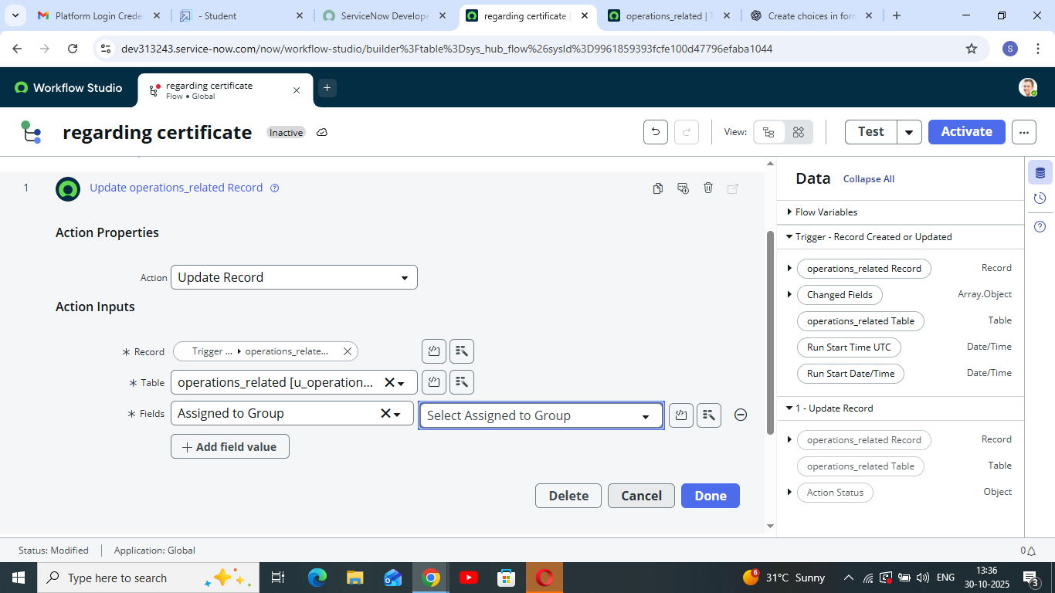

4. Logical Data Flow
When a new ticket is created, the system checks the Issue field and automatically routes the ticket based on defined flow logic. Tickets marked as 'Regarding Certificates' are routed to the Certificates Group, while those tagged as 'Platform-related' (login, 404, expired) are sent to the Platform Group. This logic eliminates the need for human assignment and ensures faster handling.

5. Security and Role Management
Security is implemented through layered access control using roles and ACLs. Only users with specific roles can view or edit records in the Operations Related table. Admins maintain oversight through elevated privileges while ensuring that operational users can access only relevant modules.

6. Expected Outcomes
The designed system delivers automated, accurate, and efficient ticket routing. Key expected results include:
• Reduction in manual ticket handling.
• Improved accuracy of team assignment.
• Enhanced resolution speed and customer satisfaction.
• Streamlined access control ensuring secure operations.
• Improved internal coordination and SLA adherence.

